⛕ - 1

Å / Å / Å - 2

§ / § / § - 3

Ϥ / Ϥ / Ϥ - 4

ϓ - 5

♅ ♅ - 6

♇ - 7

♑ / 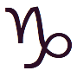 - 8

♃ ♃- 9

ᴂ - 10

᱘ - 11

ↈ ↈ - 12

ⵥ - 13

⟇ - 14

👁/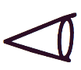/ 9215 - 15

∮ - 16

២ / - 17

Ⴥ - 18

ϡ ϡ ϡ - 19

ჭ ჭ - 20

/ᱷ - 21

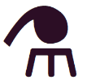 - 22

 [hj] - 23 https://unicode-table.com/en/1CC4/

⛣ - 24

[arrow&dot] - 25

**₿/**Ƀ/- 26

Ⱙ - 27

ਛ - 28

ಥ 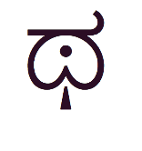- 29

ᱷ

{11,24,10, 7, 5, 2, 9},

{28, 3,27, 8,15,29, 7},

{22,25, 2,11,14,24,13},

{21,20, 6, 1, 8,16, 4},

{18,15,23,12,21,19,17},

{17,16,22,18, 1,20, 6},

{13,23,28,10, 9, 26, 3}